**Ideation Phase**

**Brainstorm & Idea Prioritization Template**

|  |  |
| --- | --- |
| Date | 27 June 2025 |
| Team ID | LTVIP2025TMID59297 |
| Project Name | Smart Sorting: Transfer Learning for Identifying Rotten Fruits and Vegetables |
| Maximum Marks | 4 Marks |

**Brainstorm & Idea Prioritization Template:**

The goal was to think freely and collaboratively about how to solve the problem of inefficient manual sorting of spoiled produce. Several innovative solutions were proposed, including using a camera with an AI model to detect rotten fruits in real-time, developing a mobile app that allows farmers to scan produce using their smartphones, integrating the model with a conveyor belt system to automate physical sorting, deploying IoT-enabled shelf sensors that detect spoilage early in storage environments, and creating a spoilage dashboard to help supervisors monitor trends and optimize quality control..

Reference: <https://www.mural.co/templates/brainstorm-and-idea-prioritization>

**Step-1: Team Gathering, Collaboration and Select the Problem Statement**

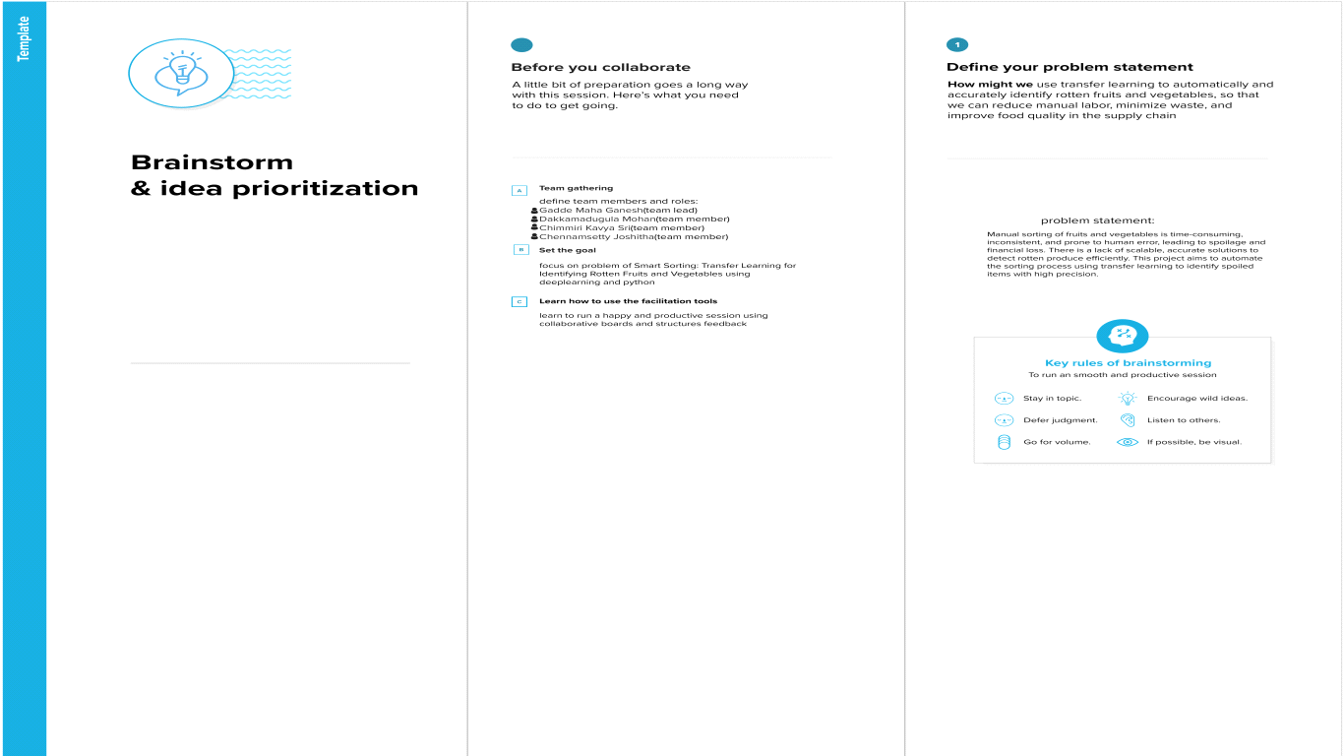

**Step-2: Brainstorm, Idea Listing and Grouping**

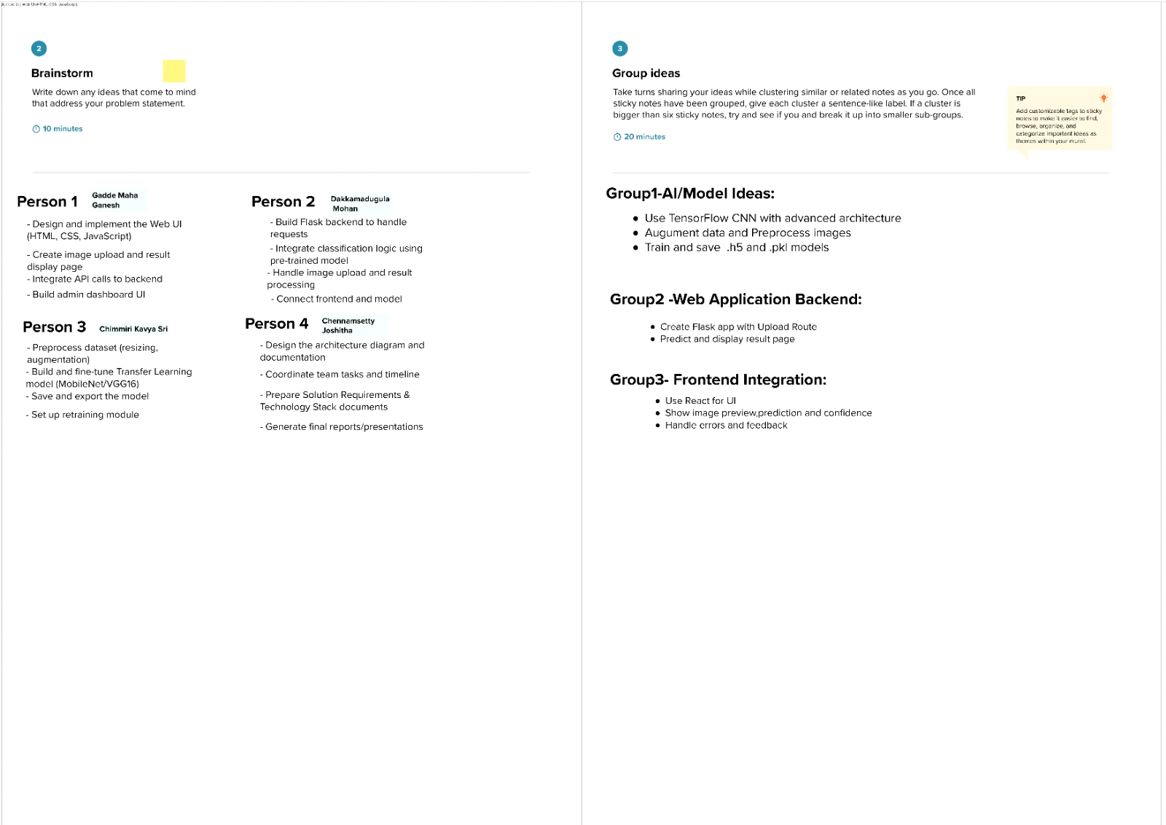

**Step-3: Idea Prioritization**

